**IT 592 – Graduation Project Proposal**

**Project Title: Auction Web Site**

**Group Members:**

**Deniz ÇAKAR - Birgün GÜNEŞER**

**Date: 23.06.2019**



1. **ABSTRACT**

Main purpose of the Project is live tendering. Each product should flow on main page with features, kick-off price and date when tendering will start. when registered user click on product, user can figure out all detail of tender like duration, begining of date, price, other users activity(number of active user in tender room) and historical average price. If product has been already in live tender, registered users can attend tender room of related product. Each user who would like to buy product has to increase [introductory price](https://tureng.com/en/turkish-english/introductory%20price)  of it at least 20 pecentage. If there is no bet in the product auction, the product should be sold at the first opening price for first intended user. Only registered user can attend to live tender session, others can view tender flow.

The online auctioning system is a flexible solution for supporting lot- based online auctions. The project explains the construction of an auction website. The system has been designed to be highly-scalable and capable of supporting large numbers of bidders in auction. The online auction system lets you easily browse lots and place bids using a secure server. All cost of mailing lots will be paid by the buyer. The objective is to develop a user-friendly auctioning site where any kind of product can be auctioned and provide value added services to the bidders and the sellers. The products will be authenticated and the site provides a safe environment for online users.

# INTRODUCTION

There are multiple factors that determine the price of a product. first is production cost, other is amount of demand on product by buyers. When we evaluate both case the most important factor is demand over price increment of a product. In order to evaluate price increment, auction system is one of the best methodology by this way each buyer can monitor pricing and demand at the same time. There are several different types of auctions which may include minimum price limit, maximum price limit and time limitations as a rule. Depending upon the auction method bidder can participate remotely or in person. Remote auction include participating through telephone, mail, and internet. Shopping online has widely grown; online auction system is increasing rapidly. Online auction is becoming more and more popular in electronic commerce and hence it should system must increase its quality and security.

One of the most significant thing is easy accessibility and search of a product in online auction for buyer and sellers’ point of view. In order to provide these features, categorization flow is determining parameter. From point of buyer view, they have to add their product by saving all features of products other supportive criteria is crystal clear web pages for functionality for instance adding to chart, login, registration, search by category etc. Taking as reference eBid, uBid, Webstore.com ve LiveAuctioneers have been benchmarked as a result, LiveAuctioneers website is well-designed for variety of categeroy search and finding demanded product however, Webstore.com is not user friendly at first inspect and late responsive

# PROPOSED SOLUTION AND METHODS

* What do you suggest to solve exactly?

Convenience : you can make offers no matter your location

Open 24/7 : you can place offers at all hours of the day

Instant Feedback : receive instant feedback. As the price increases from bids, you will be able to see and adjust your own bids, if interested.

Save Your Precious Time and Money : By doing your shopping online, you won’t waste time traveling to a bunch of properties

Variety of Choices : Websites will allow you to select exactly what you are looking for and filter out the rest.

* What is the scope (what is covered and not covered)?

**Covered scope**

* Online Auctions know no geographical barriers
* Levels the playing field and attracts the right buyers
* Online auctions are universal
* Everything takes place live; time isn’t a detriment
* The allure of great deals is irresistible
* Quick and reliable transactions
* Reasonable Pricing

**Uncovered scope**

* Anonymous bidder
* Product Genuiness
* Agreement guarantee between buyer and sellers
* Many potential buyers want instant satisfaction and are unwilling to wait end of auction date to find out they lost to a last minute sniper
* Untrackable under 18 age user

## Objectives/Tasks

The Objective is to develop a user-friendly auctioning site where any kind of product can be

auctioned and provide value-added services to the bidders and the sellers. The products will be authenticated and the site provides a safe environment for online users

* Secure registration of all users including a personal profile Administrators would authorize the product to auction, set auction dates and Minimum auction amount for that product.
* Prior to each bid, the user’s bank or credit account must be authenticated for available balance required for the bid.
* Complete Search/Site Map of the entire site for easy access.
* Discussion forums for users to interact with other users to know about the product’s value and originality.
* Online Legal Documentation to avoid disputes. Guidance to the users about the same must be available.
* Rare articles may be withheld by owner on the advice of the administrator to be thrown open in special auctions held by the site so as to increase the bid-values.

The project will make use of a database and a web server that can be accessed with any web browser. There are 3 types of users on the system: guests, rag- interred users, administrators users. Before a user can make use of the full functionality of the site, the user has to register. The user will have to enter some personal information in a form in order to accomplish this. Only users of at least 18 years old will be allowed due to legal reasons. Both guests and users can browse the deferent auctions, but only registered users can bid on auctions or place their own auctions. Users can browse through auctions with categories or tags. When a seller places an auction, specify payment methods, transport methods, a minimum price, duration for the auction and other general information about the auction have to be specified . A buyer can follow an auction. The followed auctions list is a list of auctions that interest the buyer but on which buyer may not have bid yet. Then when the user wants, buyer can bid on the auction. A user can view all the auctions he or she has bid on in the active auctions list. When a user has won an auction, buyer can pay for the item. This will be done through a transaction. The buyer can pay for the item by choosing on of the payment options the seller has specified. One of these methods is through sales pal. This a personal \bank account" on the site that each user has. Buyers can pay for items with the money on this account and sellers can receive money on their sales pal account. Users can top up their sales pal account, i.e. they transfer money to the account. When the transaction is done, buyers and sell- errs can rate the transaction. Each user will have a rating then which is based on the ratings of their transactions.

Users can also contact other users through personal messages. Other sellers can also be added to a favorite sellers list, so that a user can easily check if a seller they like has new auctions.

Administrators have some extra functionality; they can manage the users and auctions. Administrators can also retract a bid of a user.

**User Characteristics**

The users of the system will be users with deferent levels of technical expertise. Any user with a basic

understanding of the internet and auctions should be able to make use of all the available

functionality of the system.

There are three deferent types of users:

Guests: These are visitors of the site which don't have an account yet or aren't logged in.

Users: These are users of the site who have an account and are logged in.

Administrators: These are special members of the site who manage the site.

## Realistic Constraints

Economic : Google Cloud + Deployment + Maintenance : 1000 $ per month

Security : Clear Consent – Term Of Use – Clarification Text Agreement with Users

Manufacturability : CPU with 4 Core + 512 GB SSD + 16GB RAM for server

Sustanability : Shopping habits have been evolved to web-based system in last decades. Keep website reliable and secure, improving network between sellers and buyers and implement latest technologies will contribute to sustainability of website.

# RISK MANAGEMENT

* What happens if you cannot acquire or use a planned resource?

Stand-by backup technologies such as spring, firebase, mongodb, vue etc. taken into account in case of unexpected situations

Gantt chart has been prepared for implementing backup technologies and test

* What happens if you require expertise you do not have in your team?

Benefits of software specialist in our companies

Advice from lecturers

* What happens if you find out that one or more components in the project require longer delivery/development or manufacturing time?

Agile methodology will be followed up for project management

# PROJECT SCHEDULE

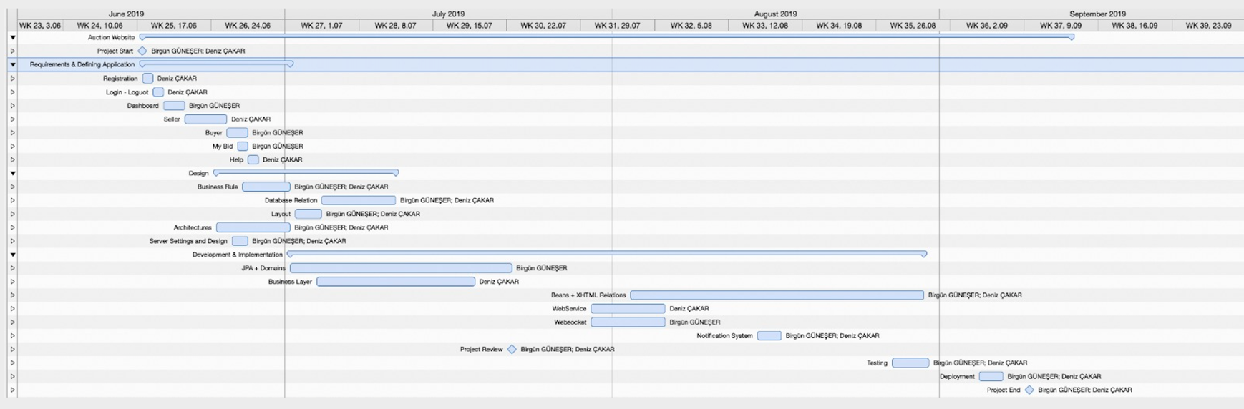

# ETHICAL ISSUES

* *Product price can be artifically inflated*
* *Misalignment between product features and pictures depend on seller*
* *Does not authanticate agreement between seller and buyer*
* *Shill Bidding*
* *price negotiation between sellers and buyers after auction*

# REFERENCES

* Stancapiano L. 2017 Mastering Java EE Development with WildFly,Book, BIRMINGHAM - MUMBAI
* Burns E., Schalk C., 2010 JavaServer Faces 2.0: The Complete Reference, Book, New York Chicago San Francisco Lisbon London Madrid Mexico City Milan New Delhi San Juan Seoul Singapore Sydney Toronto
* Basham B.,Sierra K.,Bates B., 2008 Head First Servlet & JSP United States
* <https://docs.oracle.com/javaee/6/tutorial/doc/bnbpz.html>
* <https://www.w3schools.com/>
* <https://www.ebid.net/us/>
* <https://www.liveauctioneers.com/>